**COMPUTER SCIENCE PROJECT**

**TOPIC: STUDENT REPORT CARD AND DATA MANAGEMENT OF STUDENT DETAILS**

**DONE BY: SANTOSH**

**ACADEMIC YEAR: 2019- 2020**

**BONAFIDE CERTIFICATE**

Certified bonafide for the Computer Science Project work done by Santosh

Reg.No. 20611340 during the academic year 2019-2020.

DATE: INTERNAL EXAMINER

DATE: EXTERNAL EXAMINER

Submitted for the All India Senior Secondary Practical Examination for the subject COMPUTER SCIENCE at KOLA PERUMAL CHETTY VAISHNAV SENIOR SECONDARY SCHOOL, Arumbakkam, Ch-106.

PRINCIPAL

***Acknowledgement:***

I take this opportunity to express a deep sense of gratitude to **Shri L. Neelakanta Pillai**, Director and **Shri T. Ramasubramanian**, Principal, for their cordial support and guidance which helped me in completing the task through various stages.

It would be my utmost pleasure to express my profound gratitude and deep regards to my Computer Science Teacher **Smt. K. Sasikala** for her exemplary guidance, monitoring and constant encouragement throughout the course of this project. The blessing, help and guidance given by her shall carry me a long way in the journey of life on which I’m about to embark.

I am obliged to the management of the school for providing quality apparatus in the lab and also giving me the golden opportunity to carry out this project.

It is also my duty to thank my lab attender **Mr. Ramesh Kumar** for readily helping me with the required apparatus whenever I required it.

Lastly, I thank the almighty, my family, friends, and all others for their constant encouragements without which this assignment would not be possible.

Thanking You,

Santosh

***PROJECT ANALYSIS:***

This C++ mini project on **STUDENT REPORT CARD AND DATA MANAGEMENT OF STUDENT DETAILS** has student class with data members like Roll Number, Name, Marks and Grade. Member Functions in this class are used for accept/display details of students and a function to calculate grade based on marks obtained by student. Student Records are stored in a binary file.

This menu driven program illustrates read, write, search, modify and delete operations in binary file.

This project would help users to write data of different students. It can also be used to edit the existing data by removing, modifying or by creating a new data.

***HEADER FILES USED:***

#include<fstream.h>

#include<iomanip.h>

#include<stdio.h>

#include<conio.h>

#include<process.h>

#include<fstream.h>

#include<iomanip.h>

#include<stdio.h>

#include<conio.h>

#include<process.h>

class student

{

int rollno;

char name[50];

int p_marks,c_marks,m_marks,cs_marks,e_marks;

float per;

char grade;

void calculate();

public:

void getdata();

void showdata();

void show_tabular();

int retrollno();

};

void student::calculate()

{

per=(p_marks+c_marks+m_marks+cs_marks+e_marks)/5;

if(per>=89.99)

grade='A1';

else if(per>=79.99)

grade='A2';

else if(per>=69.99)

grade='B1';

else if(per>=59.99)

grade='B2';

else if(per>=49.99)

grade='C1';

else if(per>=39.99)

grade='C2';

else if(per>=31.99)

grade='D';

else if(per>=19.99)

grade='E1';

else if(per>=0)

grade='E2';}

void student::getdata()

{

cout<<"\n Enter the Roll Number of the Student: \t";

cin>>rollno;

cout<<"\n Enter the Name of the Student: \t";

gets(name);

cout<<"\n\n\t\t All the Marks are out of 100.";

cout<<"\n Enter the Marks in Physics: \t";

cin>>p_marks;

cout<<"\n Enter the Marks in Chemistry: \t";

cin>>c_marks;

cout<<"\n Enter the Marks in Mathematics: \t";

cin>>m_marks;

cout<<"\n Enter the Marks in Computer Science : \t";

cin>>cs_marks;

cout<<"\n Enter the Marks in English: \t";

cin>>e_marks;

calculate();

}

void student::showdata()

{

cout<<"\n Roll Number of Student: \t"<<rollno;

cout<<"\n Name of Student: \t"<<name;

cout<<"\n Marks in Physics: \t"<<p_marks;

cout<<"\n Marks in Chemistry: \t"<<c_marks;

cout<<"\n Marks in Mathematics: \t"<<m_marks;

cout<<"\n Marks in Computer Science: \t"<<cs_marks;

cout<<"\n Marks in English: \t"<<e_marks;

cout<<"\n Percentage of Student: \t"<<per;

cout<<"\n Grade of Student: \t"<<grade;

}

void student::show_tabular()

{

cout<<rollno<<setw(6)<<"\t"<<name<<setw(10)<<p_marks<<setw(4)<<c_marks<<setw(4)<<m_marks<<setw(4)<<cs_marks<<setw(4)<<e_marks<<setw(6)<<per<<setw(6)<<"\t"<<grade<<endl;

}

int student::retrollno()

{

return rollno;

}

void write_student();

void display_all();

void display_sp(int);

void modify_student(int);

void delete_student(int);

void class_result();

void result();

void intro();

void entry_menu();

int main()

{

char ch;

cout.setf(ios::fixed|ios::showpoint);

cout<<setprecision(2);

clrscr();

intro();

do

{

clrscr();

cout<<"\n\n\t\t\ MAIN MENU";

cout<<"\n\t 1. RESULT MENU";

cout<<"\n\t 2. ENTRY/EDIT MENU";

cout<<"\n\t 3. EXIT";

cout<<"\n\t Please Select your Option: \t";

cin>>ch;

clrscr();

switch(ch)

{

case '1':

result();

break;

case '2':

entry_menu();

break;

case '3':

exit(0);

break;

default:

cout<<"\a";

}

}

while(ch!='3');

return 0;

}

void write_student()

{

student st;

ofstream f1;

f1.open("student.dat",ios::binary|ios::app);

st.getdata();

f1.write((char*)&st,sizeof(student));

f1.close();

cout<<"\n Student Record has been Created.";

cin.ignore();

getch();

}

void display_all()

{

student st;

ifstream f2;

f2.open("student.dat",ios::binary);

if(!f2)

{

cout<<"\n File does not EXIST..!!!";

cout<<"\n Press any key to continue.";

getch();

return;

}

cout<<"\n\n\t\t DISPLAY ALL RECORDS !!! \n\n";

while(f2.read((char*)&st,sizeof(student)))

{

st.showdata();

cout<<"\n\n==================\n";

}

f2.close();

getch();

}

void display_sp(int n)

{

student st;

ifstream f2;

f2.open("student.dat",ios::binary);

if(!f2)

{

cout<<"\n File does not EXIST..!!!";

cout<<"\n Press any key to continue.";

getch();

return;

}

int flag=0;

while(f2.read((char*)&st,sizeof(student)))

{

if(st.retrollno()==n)

{

st.showdata();

flag=1;

}

}

f2.close();

if(flag==0)

cout<<"\n File does not EXIST..!!!";

cout<<"\n Press any key to continue.";

getch();

}

void modify_student(int n)

{

int found=0;

student st;

fstream f;

f.open("student.dat",ios::binary|ios::in|ios::out);

if(!f)

{

cout<<"\n File does not EXIST..!!!";

cout<<"\n Press any key to continue.";

getch();

return ;

}

while(f.read((char*)&st,sizeof(student))&&found==0)

{

if(st.retrollno()==n)

{

st.showdata();

cout<<"\n Please Enter the New Details of the Student:"<<endl;

st.getdata();

int pos=(-1)*sizeof(st);

f.seekp(pos,ios::cur);

f.write((char*)&st,sizeof(student));

cout<<"\n\t RECORD UPDATED !!!";

found=1;

}

}

f.close();

if(found==0)

cout<<"\n Record does not EXIST..!!!";

cout<<"\n Press any key to continue.";

getch();

}

void delete_student(int n)

{

student st;

ifstream f2;

f2.open("student.dat",ios::binary);

if(!f2)

{

cout<<"\n File does not EXIST..!!!";

cout<<"\n Press any key to continue.";

getch();

return;

}

ofstream f1;

f1.open("Temp.dat",ios::out);

f2.seekg(0,ios::beg);

while(f2.read((char*)&st,sizeof(student)))

{

if(st.retrollno()!=n)

{

f1.write((char*)&st,sizeof(student));

}

}

f1.close();

f2.close();

remove("student.dat");

rename("Temp.dat","student.dat");

cout<<"\n RECORD DELETED !!!";

getch();

}

void class_result()

{

student st;

ifstream f2;

f2.open("student.dat",ios::binary);

if(!f2)

{

cout<<"\n File does not EXIST..!!!";

cout<<"\n Press any key to continue.";

getch();

return;

}

cout<<"\n\n\t\t ALL STUDENTS' RESULTS !!!";

cout<<"===================================================\n";

cout<<"R.No. Name P C M CS E Percentage Grade"<endl;

cout<<"===================================================\n";

while(f2.read((char*)&st,sizeof(student)))

{

st.show_tabular();

}

getch();

f2.close();

}

void result()

{

char ch;

int rno;

cout<<"\n\n\t\t RESULT MENU";

cout<<"\n\t 1. CLASS RESULT";

cout<<"\n\t 2. STUDENT REPORT CARD";

cout<<"\n\t 3. BACK TO MAIN MENU";

cout<<"\n\t Enter your Choice \t";

cin>>ch;

switch(ch)

{

case '1':

class_result();

break;

case '2':

cout<<"\n Enter the Roll Number of the Student: \t";

cin>>rno;

display_sp(rno);

break;

case '3':

exit(0);

break;

default:

cout<<"\a";

}

}

void intro()

{

cout<<"\n\t STUDENT REPORT CARD AND DATA MANAGEMENT OF STUDENT DETAILS";

cout<<"\n Name: Santosh";

cout<<"\n Std/Div: XII/A";

cout<<"\n School: Kola Perumal Chetty Vaishnav Senior Secondary School";

getch();

}

void entry_menu()

{

char ch;

int num;

clrscr();

cout<<"\n\n\t\t ENTRY MENU";

cout<<"\n\t 1. CREATE STUDENT RECORD";

cout<<"\n\t 2. DISPLAY ALL STUDENTS' RECORDS";

cout<<"\n\t 3. SEARCH STUDENT RECORD";

cout<<"\n\t 4. MODIFY STUDENT RECORD";

cout<<"\n\t 5. DELETE STUDENT RECORD";

cout<<"\n\t 6. BACK TO MAIN MENU";

cout<<"\n\t Please Enter your Choice: \t";

cin>>ch;

switch(ch)

{

case '1':

write_student();

break;

case '2':

display_all();

break;

case '3':

cout<<"\n Enter the Roll Number of the Student: \t";

cin>>num;

display_sp(num);

break;

case '4':

cout<<"\n Enter the Roll Number of the Student: \t";

cin>>num;

modify_student(num);

break;

case '5':

cout<<"\n Enter the Roll Number of the Student: \t";

cin>>num;

delete_student(num);

break;

case '6':

exit(0);

break;

default:

cout<<"\a";

entry_menu();

}

}

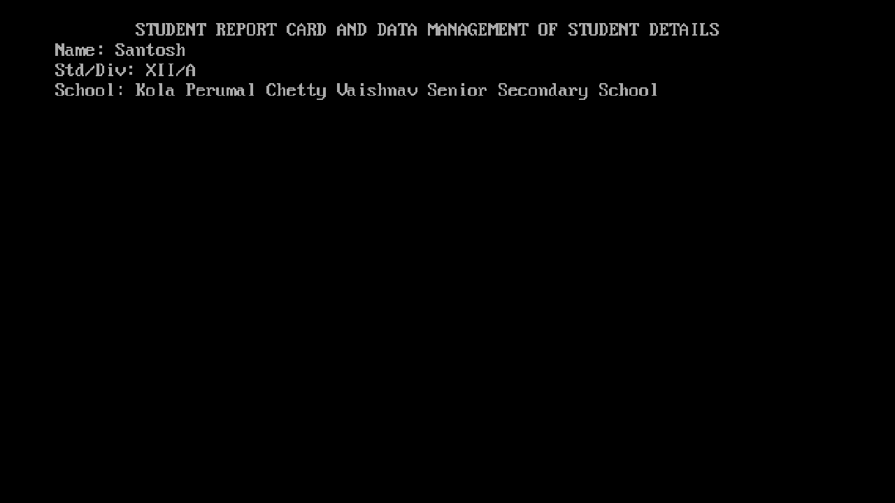

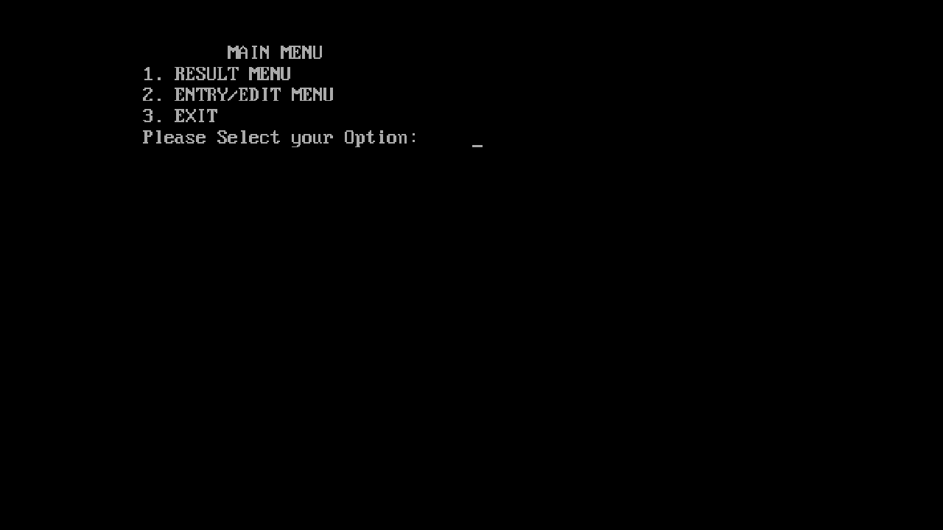

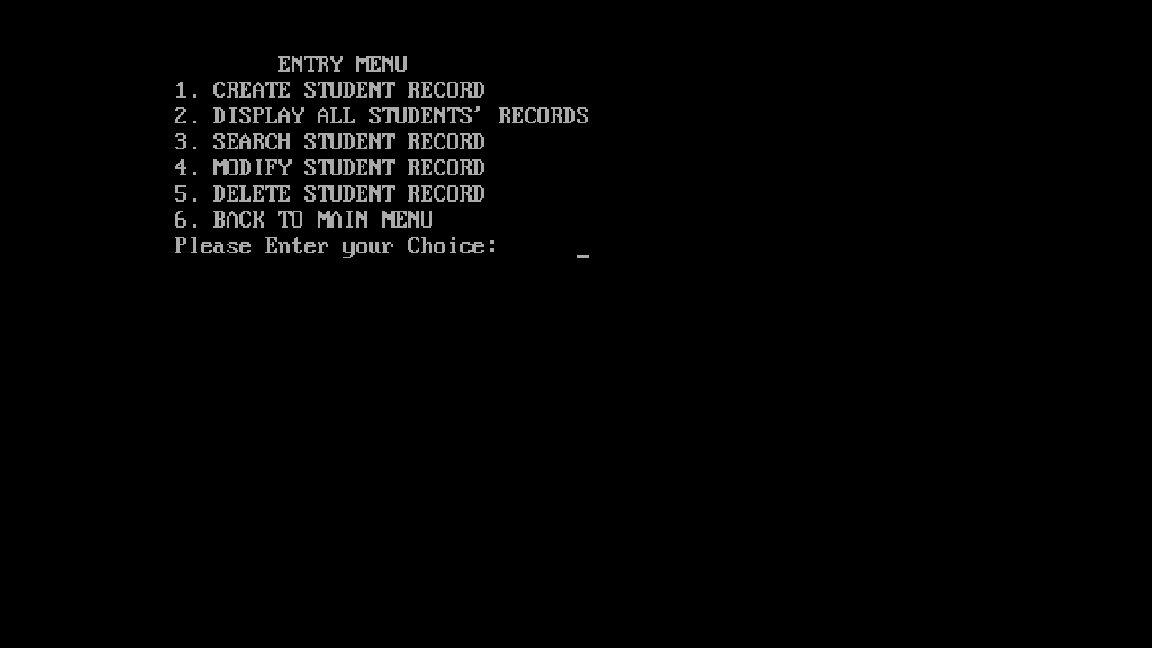

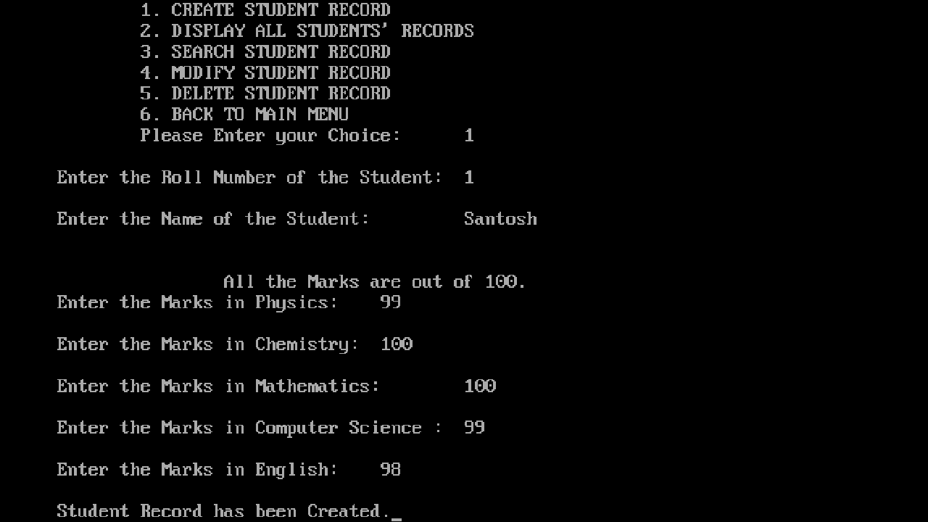

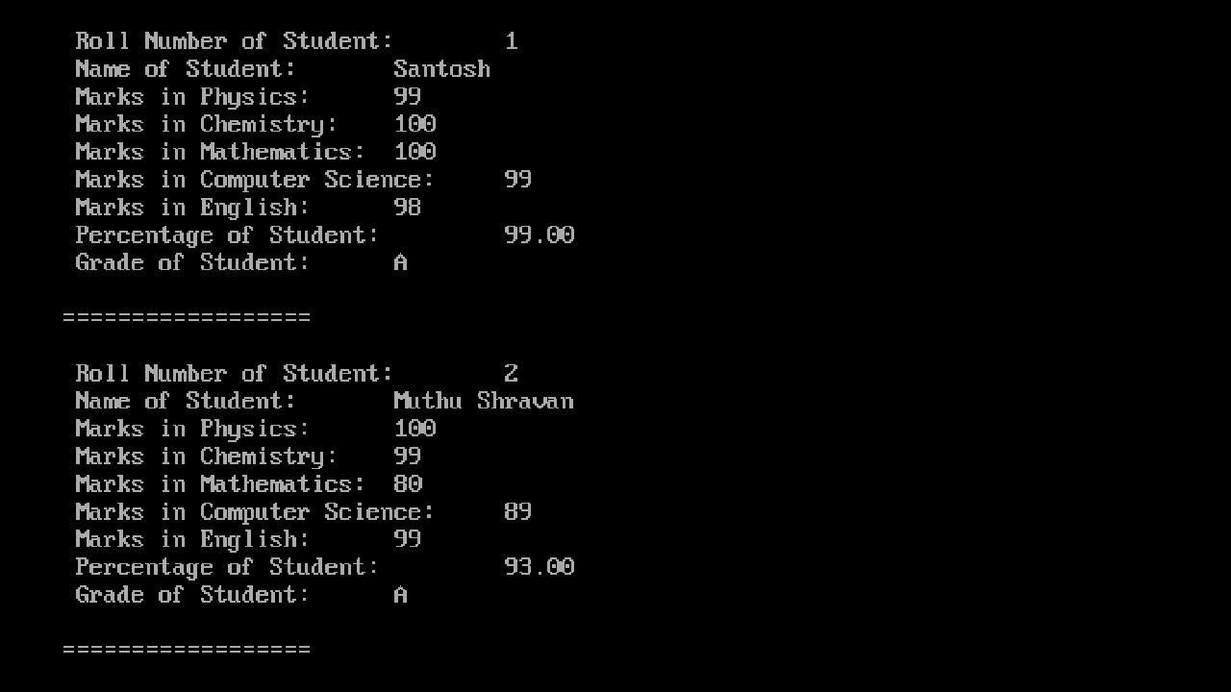

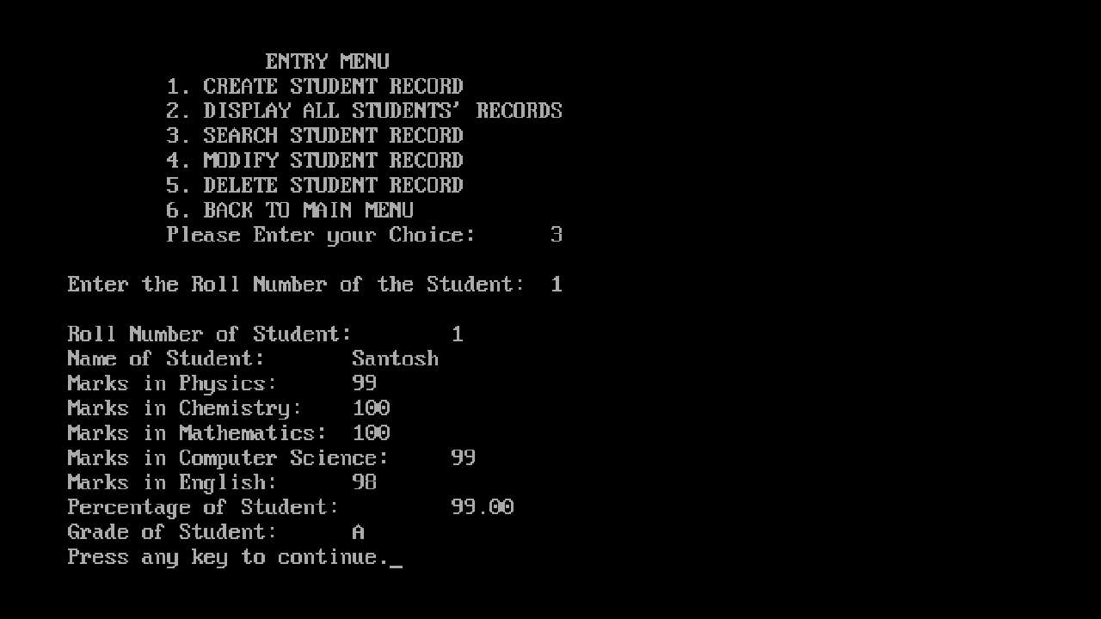

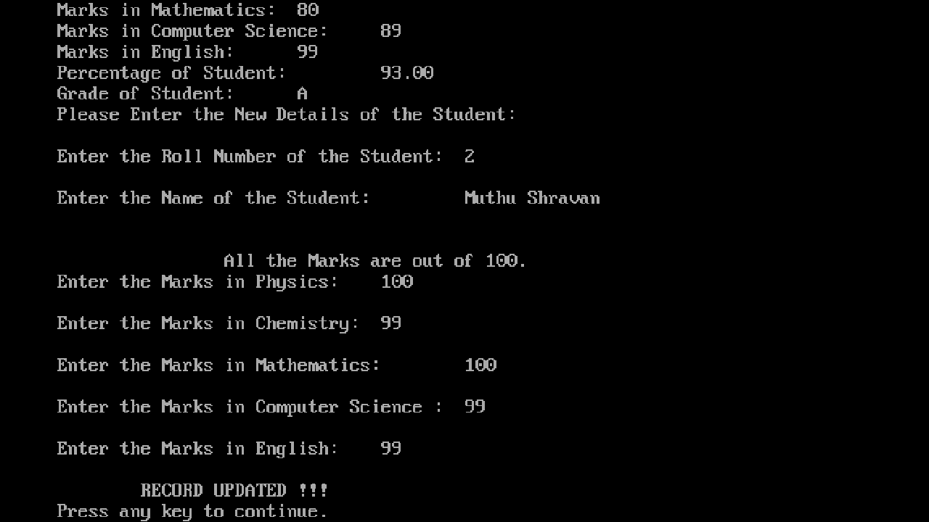

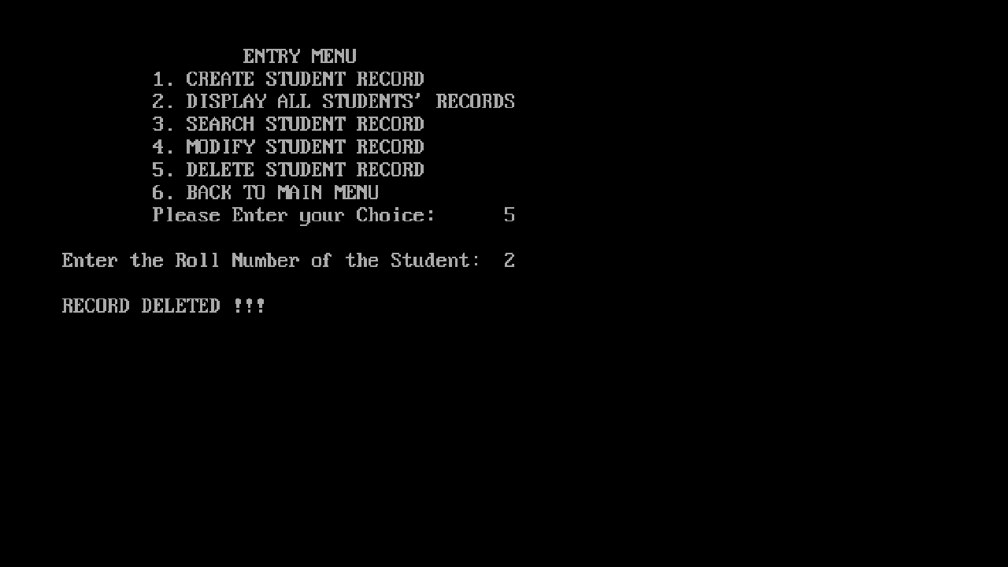

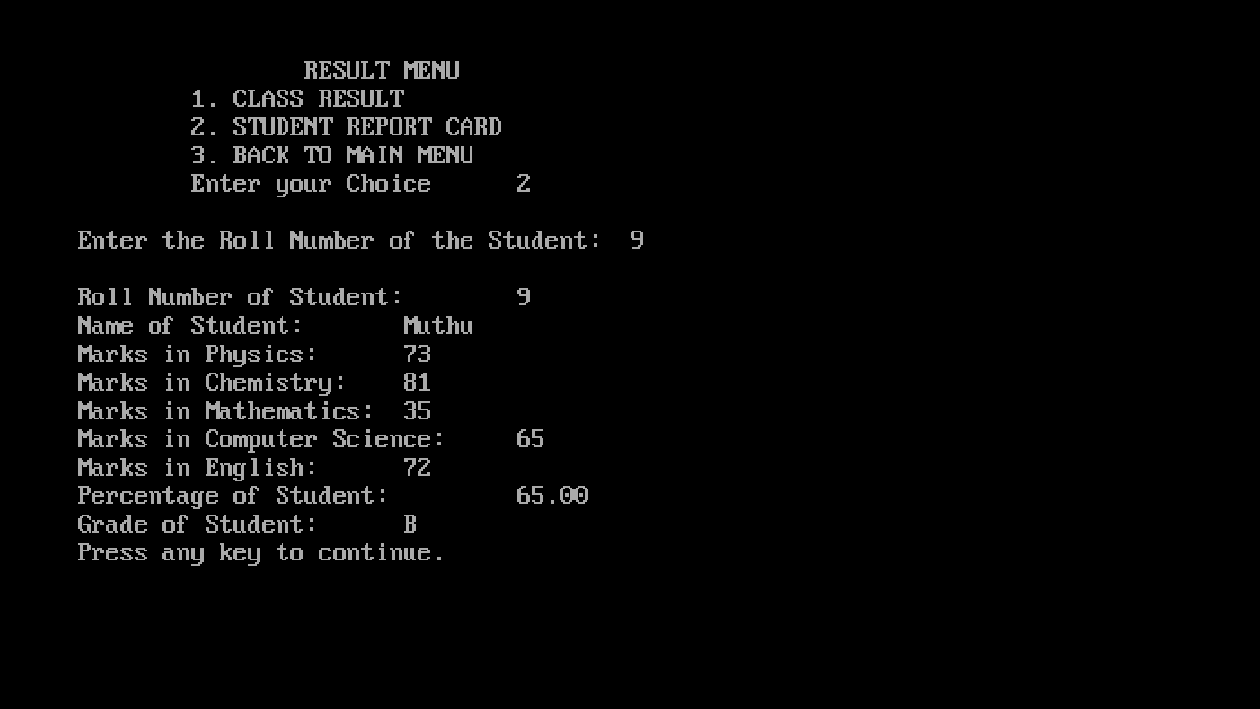

***BIBLIOGRAPHY:***

* Computer Science with C++ by Sumita Arora (Class XI)
* Computer Science with C++ by Preeti Arora and Pinky Gupta (Class XII)
* Turbo C++ Help Index